RESPONSE TO Clarification request No. 1

Ref no: 1704988/04.12.2020

QUESTION:  *1.*Please clarify exactly which part of the car body should be covered with tarpaulin and which parts should be equipped with the metal shutters.

RESPONSE 1: The car-body will be made of fixed platform with metal shutters (shutter = panel, side wall) of at least 900 mm height. On the shutters will be mounted the metallic shed (shed = springs, bars) which will be removable. The tarpaulin must cover the car-body over the sheds, at least above the metal shutters.

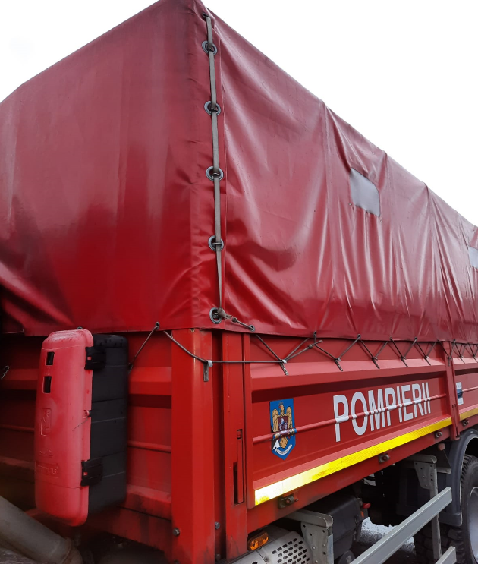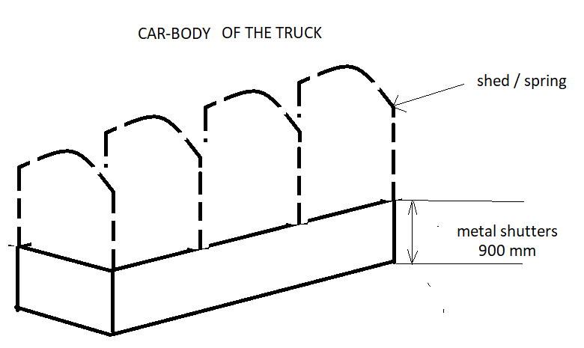

(example of an similar truck)

QUESTION:  *2.*Please clarify what you mean by removable type metallic shed and self-supporting tarpaulin

RESPONSE 2: The metallic shed (bars, springs) and the tarpaulin must be completely removable.

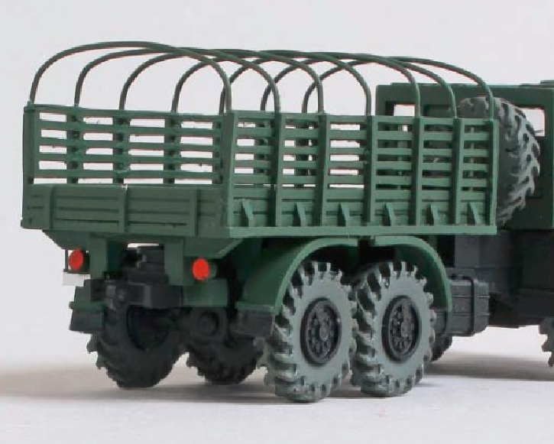 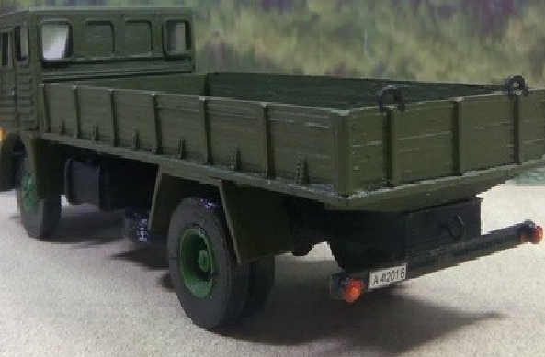

(toy trucks pictures for a better understanding)

QUESTION: 3.       Should the work light lamp be installed inside the cabin for work within the vehicle?

RESPONSE 3: The work light lamp (projector) will be installed outside the cabin, “*12.10.3* *…. in the front right side of the cab, detachable, with 2-way: up-down or left-right beam orientation”.*

QUESTION: 4.       „12.10.4. Coupling to the truck's electrical system will be done with a moisture-proof plug in the cab near the projector via the projector's cable.” What is the projector in the above sentence? There is no mention of it earlier.

RESPONSE 4: The projector it means “the work light lamp”.

QUESTION: 5.       Please clarify what you mean by the projector meant to illuminate the rear loading / unloading process. If the work light lamp’s plug should be near the projector, how can the projector be in the rear of the superstructure?

RESPONSE 5: The projector (work light lamp) will be used either to illuminate in the front of the vehicle when will be necessary (for example during the night missions), or in the back of the truck during the night operations when it is necessary to load/ unload materials. That’s why the projector should be detachable and with the possibility to be placed in a bracket positioned in the rear of the truck.

In fact, what is wanted is to increase the illumination in front and side of the truck, and to ensure the illumination of the loading-unloading operations of the truck during the night. Therefore, in addition to the work lamp placed in the front of the truck, any other lighting options that the manufacturer may present may be considered, so that the requirements of point 12.10.5 from Technical Specifications can be met.